Design Outline:

Create an array of student names, then create a for loop that cycles through each name in the array. Within the for loop I will have a function that first gets inputs from the user for each class topic (discussion, quiz, assignment) and then returns these values as an array. Next in the for loop I will have another function that takes this previous array as input and calculates the average grade based on the given formula. Additionally the loop will track the current highest grade and whenever a new highest grade is achieved the value will be saved to a variable along with the students name. within my input function I will have constraints to make sure the user can only input valid values for grades (0 <= grade <= 100, float values only)

Test plan:

Test that invalid user inputs are rejected (non floats, non normal grade values)

Test that the student with the highest average grade is properly calculated and displayed

Test that in the case of a tied highest grade the first student with the highest grade is displayed

Test 1:  
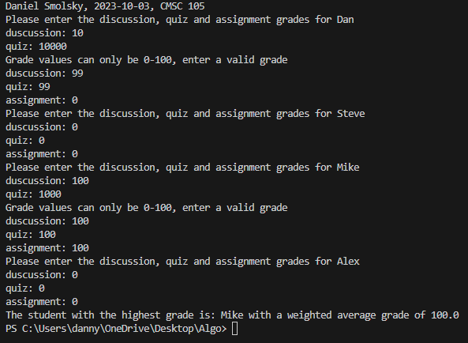

Test 2:

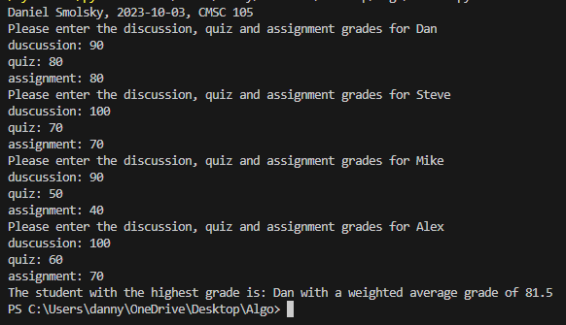

Test 3:

